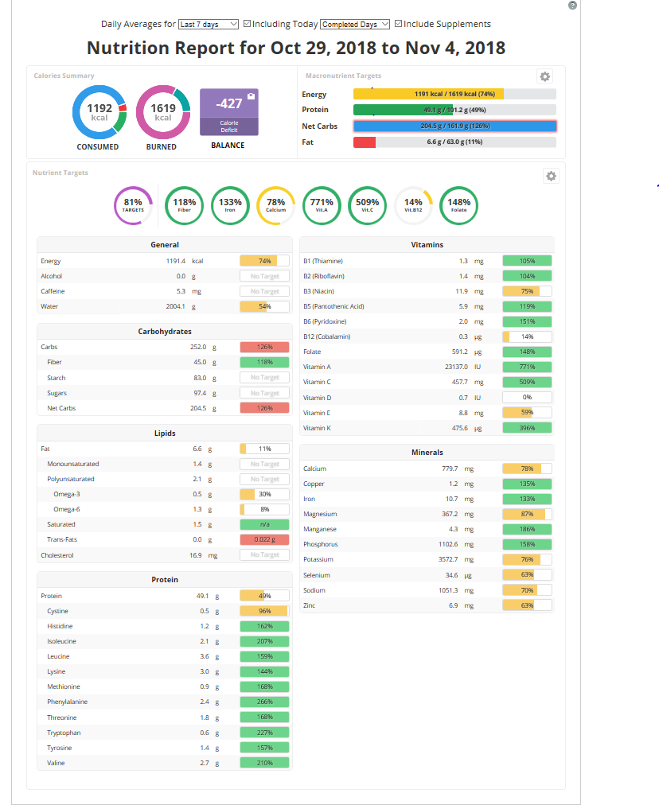

Table one
Macronutrients | DRI  Goal or Target  (EER, RDA, AI) | 3-Day Average  (g or kcals) | % of Recommended  Intake (DRI) | Status | List your highest  food source
Calories (kcal) | 1191.4 Calories/day= 2 kcals | 1081 Calories  1.081 kcals | 54.05% | Under | Broccoli raw
Carbohydrate (grams) | 252.0 g | 139 g | 106% | OK | Beans, canned and dried
Fiber (grams) | 45 g | 7 g | 28% | Under | 100% Whole Wheat Bread
Fat (grams) | 20-35% Calories | 28% Calories | 101% | OK | Baskin-Robins, Non-fat
Saturated Fat (grams) | < 10% Calories | 10% Calories | 100% | Over | Apple, fresh, with skin
Protein (grams) | 36 g | 56 g | 121% | OK | Banana
Cholesterol | < 200 mg  <0.20000 g | 123 mg = 0.12300 g | 41% | OK | Sweet potato, boiled
Omega 3 Fatty Acids  (both EPA and DHA) | 1.1 g | EPA: 0.0030000g  DHA:0.0060000g | 0.27% | Under | Chicken breast, boneless, roasted

Table 2
 | 1 | 2 | 3 | 4 | 5 | 6
 | DRI Goal or Target  (EER, RDA, AI) | 3 Day Average  Vitamin /Mineral Intake | % RDA or AI supplied | % Kcal RDA supplied* | Nutrient density ratio | Status
Vitamin A | 700 μg/day | 249 μg/day | 35.57% | 54.95% | 0.65 | Under
Vitamin D | 15 IU/day | 2 IU/day | 13.3% | 54.95% | 0.24 | Under
Vitamin C | 75 mg/day | 49 mg/day | 65.3% | 54.95% | 1.19 | Under
Thiamin | 1.1 mg/day | 1.0 mg/day | 90.9% | 54.95% | 1.65 | Under
Riboflavin | 1.1 mg/day | 1.7 mg/day | 154.55% | 54.95% | 2.81 | OK
Niacin | 14 mg/day | 24 mg/day | 171.43% | 54.95% | 3.11 | OK
B6 | 1.3 mg/day | 1.8 mg/day | 138.46% | 54.95% | 2.52 | OK
B12 | 2.4 μg/day | 5.5 μg/day | 229.17% | 54.95% | 4.17 | OK
Folate | 400 μg/day | 415 μg/day | 103.75% | 54.95% | 1.89 | OK
Calcium | 1000mg/day | 466 mg/day | 46.6% | 54.95% | 0.84 | Under
Iron | 18 mg/day | 10 mg/day | 55.56% | 54.95% | 1.01 | Under
Sodium | <2300 mg/day | 2354 mg/day | 102.35% | 54.95% | 1.86 | Over

